

http://www.casesladder.com

Service Kit

CONTENTS PAGE

Your Solution 1
Case’s Ladder Services 1
Co-branded Customization 2
Revenue Shares 2
API Integration 2
Inhouse vs. Outsourcing 2
What is Case’s Ladder 3
Ladders 4
Tournaments 6
Community 8
MyLeague 8
Conclusion 8
YOUR SOLUTION

In today’s competitive marketplace the need to add value and content to your gaming service has never been greater. With over thirty online gaming services today, customers expect a new level of functionality and value to get their attention.

Yet in the real world firms are faced with finite staffing resources. This is where we can help out. Case’s Ladder offers the hottest leagues for your gaming service. We have been in the business of creating leagues for over four years and have the most advanced and popular leagues on the planet.

The attraction of our leagues can be found in our passion for providing competitive, fair, simple, accurate and fun leagues. This might explain why well over one and a half million people have joined our leagues. We have a full time staff dedicated to constantly improving our system and adding new functionality.

We can setup our ladders and tournaments for any game that allows for competitive play. These leagues are co-branded as your own and customized to look and feel like your existing service. With our API kit you can tightly integrate the leagues into your service allowing for real time reporting and many other features. Moreover, with our revenue share you will actually be generating additional revenue every month from your leagues.

You can expect to see a substantial increase in the amount of time people use your service as the result of our leagues. Case’s Ladder leagues and tournaments are a key way to add stickiness to your community. Players have reported spending an additional 62% more on their particular service after they joined our leagues.

Many major gaming services have utilized partnerships with Case’s Ladder to add new functionality to their service. These partnerships add value to their gaming services while allowing them to focus on their core business. Current services that we support include WON, Yahoo! Games, Microsoft Internet Gaming Zone, MPlayer, The Big Network, Gamestorm, Heat, Kali, Pogo, Eplay, 2AM, and Funcom.

CASE’S LADDER SERVICES

LEAGUES
Case’s Ladder offers official leagues that are created, maintained and run for your gaming service. These leagues are co-branded and customized to the look and feel like your service. We can create leagues for any game on your service that allows for one on one or team competition. All aspects of the league are handled by Case’s Ladder. With over four years of development, our leagues have evolved to become some of the most advanced on the Internet. They are simple enough to draw the younger audience; while being detailed and complex enough to draw the most hardcore gamers as well.

TOURNAMENTS
Case’s Ladder offers both daily and large scale tournaments. Our tournament program is managed by over 1100 tournament directors offering over 200 tournaments each day. Users can participate in these tournaments and win “LadderBux” to redeem towards prizes. In addition, we offer the management of large scale tournaments. These tournaments feature numerous prizes and can run over the course of several months. All aspects including optional live location-based finals can be handled by Case’s Ladder.

COMMUNITY
Case’s Ladder realizes that community is a key aspect to any successful site. Our leagues and tournaments help bring people together. The competitive aspects of our site help bring people together and close friendships are formed among participating users. In addition we offer a full array of community building tools which include live chat, message forums, instant messaging, co-browsing, Case’s news, gaming news, voting booths, gaming links and a monthly newsletter.

SUPPORT
One of the most critical aspects of any online gaming league is support. Case’s Ladder provides the highest level of support to our users. This is achieved through our uncompromising vision to total customer satisfaction. With over 450 tournament directors and 100 support ops, your customers are going to have an enjoyable experience on your leagues.

MYLEAGUE
One of the newest services offered by Case’s Ladder is the ability for users to run their own leagues. MyLeague gives the power to your users to create and run their own leagues and tournaments. They can customize the look and feel of their league and have flexible control over setup, options and rules. This service is offered free of charge to the users and no programming experience is required.

REVENUE SHARES

At Case’s Ladder we believe in long-term partnerships that benefit both parties. As part of this belief, we offer revenue sharing on the leagues we create for you. The revenue sharing can stem from either advertising or premium membership revenue. These premium memberships are optional user upgrades that include enhanced features for the users. By giving our clients a vested interest in our product, we establish a win-win situation for all involved.

CO-BRANDED CUSTOMIZATION

When you partner with someone the last thing you want is to have your users leaving to a completely different site that was supposed to be part of the functionality of your site. We recognize this concern and will work with you to create a fully customized version of our leagues for your service. This means you can expect the leagues we create for you to have a very similar look and feel to your own gaming service. Colors, style and page layout will all be matched as closely as possible to allow a smooth transition from your service to the leagues.

APPLICATION PROGRAMMING INTERFACE (API)

The gaming leagues of tomorrow will have much tighter integration between the leagues and the service where people are playing the games. No longer will reporting matches, looking up rank, or challenging another user require separate actions at another site. We want to make this a reality today. By utilizing our API, known as Real Time Reporting® (RTR®), we can work to make the leagues integrate seamlessly into your service. This will allow for a much more rich and full experience for your users.

INHOUSE VS. OUTSOURCING

With this much at stake, some gaming services have wondered if they should produce their leagues internally. When answering this, issues of cost, service, continuing maintenance, and quality all come into question. Creating and maintaining leagues is a huge undertaking. The resources, time, and money you will have to devote are substantial. All costs including ongoing tech support, development, database management, design, security, as well as the additional server and bandwidth loads must be factored into the decision. Conversely, the opportunity cost of what your staff could be doing becomes a large issue.

At Case’s Ladder we believe in doing one thing and doing it right. We focus entirely on building the best leagues possible. This is our core competency and we do it better than anyone else. This is truly the secret to our success.

How much will this partnership cost you? Nothing. In fact with our new revenue share you can expect a nice check in the mail every month. We also provide the leagues to your users free of charge. As with any partnership we will have to work together to make it succeed, but the reward will be well worth the effort.

When you partner with Case’s Ladder you are maximizing your returns and minimizing your costs. You are providing your users with the leagues they demand while not incurring the large overhead necessary to run them. A partnership with Case’s Ladder is truly a win-win situation for all parties.

WHAT IS CASE’S LADDER?

At the heart of the online gaming movement is the core desire to play against other human beings. Many players though are not content to simply play against others. They want to compete. They desire full blown leagues where they can see how they rank against the best players in the world.

Case's Ladder provides the most advanced leagues in the world for online gamers. We have leagues setup for hundreds of Internet playable games. Our leagues are created and co-branded specifically for online gaming services and game developers. We offer both ladder and tournament competition and a rich community set.

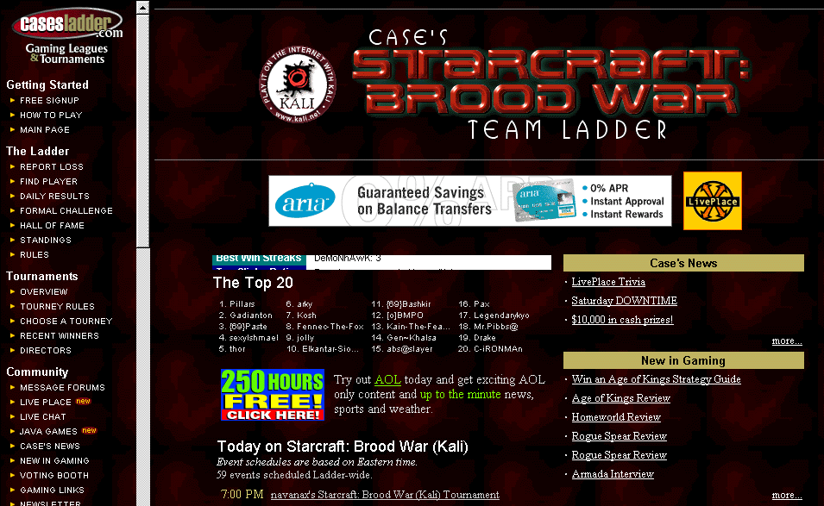
From a user’s perspective, a person will play in a match over the Internet using various methods available to them for that game. When a winner has been decided they will come to the Case’s Ladder site and post their match results. The player rankings are then automatically updated on our web site. Players can see their rank rise and fall, find out who has the most wins or losses, highest skill rating, hot players, cold players, best win percentage and much more. The appeal of Case’s Ladder is amazing and has attracted the best players in the world. The following is a sample league home page.

LADDERS

A ladder is an ongoing method of ranking players who are competing in a game. There is no end to a ladder and it can run for the life of the game with the rankings constantly changing. It is called a ladder because it operates on the principle of rank or rungs. Your ranking/rung on the ladder indicates how good you are as compared to the other players. When you sign up you start at the bottom of the ladder. Your goal is to climb the ladder to the #1 spot.

RANKING METHOD

Up, up and away!

When you beat someone you move up half the distance between their rank and yours. Example: if you were at the 100 rank and beat the #1 player, you move to 50. All players ranked 50-99 slide down one rung to make room for you.

Down we go.

What happens if you lose? Your rank remains the same. You lose rungs on the Ladder when other players jump ahead of you, forcing you down. The only exception comes when you lose to the person directly beneath you. In this case you switch spots.

The following is an example of a sample Ladder standings.

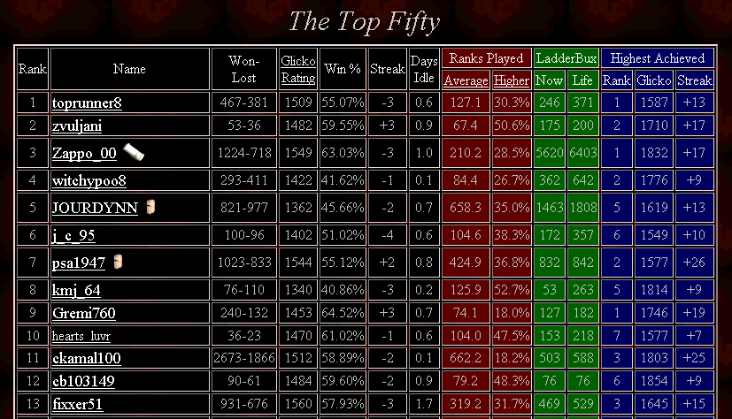

LADDER FEATURES

- Single and Team: Our ladders can be setup for all games which allow head to head or team based competition.
- Simple "Ladder" ranking system. Easy for new players to understand and yet highly accurate in determining skill.
- Matches can be played against anyone at any time of the day. This is one of the great advantages of our system which allows for quick and easy finding of matches.
- Ranks each player from top to bottom. Each player knows how they stand against their peers in an easy to see ranking display.
- Full Statistics: Daily, weekly and monthly statistics on rank, win-loss record, skill rating, win %, days idle, win-loss streaks, average rank played, percentage of games played against higher ranked players, LadderBux, highest rank achieved, highest skill rating achieved and highest streak achieved.
- Hall of Fame: Detailed historical statistics of the best players of all time.
- Dynamic Standings: Standings are generated on the fly instantly when a loss is reported. Other sites wait hours or days before rankings are updated.
- Formal Challenge: A challenge system which allows a user to challenge another specific user for a match.
- Player News: A daily news item which summarizes who's being penalized and any name changes.
- Matches Played: A summary of all matches played today or in past days.
- Search Matches: A seven day match history and news for any player.
- Match Comments: When a match has been posted the players have the ability to add comments to that match when it is posted. “Good game. You had an incredible comeback”.

TECHNOLOGY

- Hosted on an OC-12 connection with Exodus Communications for tremendous speed worldwide.
- Cisco firewalls and switches ensure high throughput and tight security.
- 24 hour monitoring enables us to achieve over 99% uptime.
- Scalable server environment allows for high growth rates without problems.
- Intel based multiprocessor machines running RedHat Linux for stability.
- Customizable look and feel to provide key statistics in any format.
- Extensive logging of all ladder related activities for security purposes.
- API available for Ladder integration into virtually any application.
- Highly automated administration allows for easy maintenance.

SUPPORT SYSTEM

Case’s Ladder has one of the most extensive support staff presence in all online gaming leagues. Support is one of the most crucial areas in an online gaming league. Without it, even an automated league will quickly fall apart and turn into chaos. We have created the best support system on the Internet for an online league. Our support system is always there to helps users with all potential problems. This includes a complete LadderOp and LadderReferee program. These positions fill many needs including providing a staff presence in chat, assisting users, answering questions, investigating potential cheating issues, and ruling on specific disputes.

STATISTICS

- 4 1/2 years in development.
- 15,000 programmer hours of development on core systems.
- Over 1,700,000 registered members.
- Over 24,000,000 matches played.
- Hundreds of games supported.
- Hundreds of LadderOps and Referees.
- 4,000 support requests handled per day.
- 3,642,000 total support requests handled.

TOURNAMENTS

Tournaments are different from ladders in that they have a definite beginning and end. The length and duration of a tournament will depend upon the format and how many people are in it. Tournaments can be run over a long period of time or be finished in one day. Our tournament system can accommodate both small user run tournaments and massive company sponsored tournaments.

User run tournaments are a key feature of Case’s Ladder. We have setup a complete system and hierarchy to manage all user run tournaments. In this system qualified users can apply to become tournament directors. Once a user has become a tournament director they can create and run tournaments for their game. These tournaments often utilize “LadderBux” as a pot for winning the tournament. LadderBux can be redeemed for prizes donated by sponsors. The end result is that there are always multiple tournaments going on each day for interested users.

In addition to user run tournaments Case’s Ladder also runs large company sponsored tournaments. These tournaments can attract anywhere from 1,000 to 100,000 people who wish to participate based on the prizes and the game’s popularity. Many game developers have utilized this as a promotion for a new game. The system though is flexible enough to be used for any type of large promotional tournament.

The following is the sample standings for a tournament.

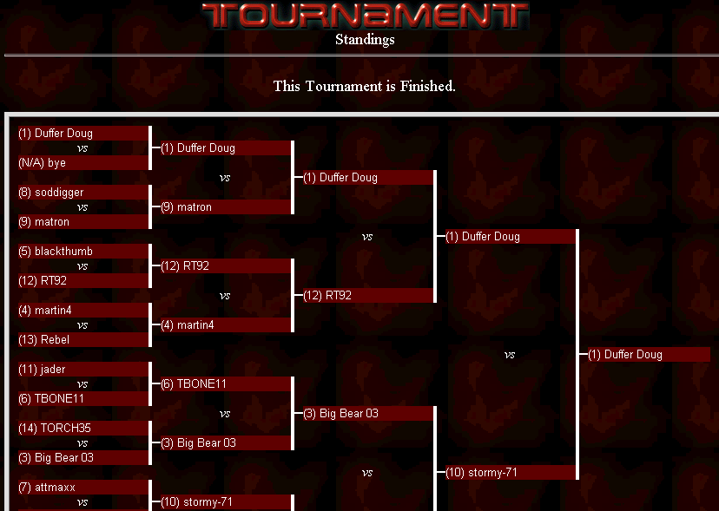

TOURNAMENT FEATURES

- Individual users can start and run their own tournament.
- Run tournament at any time during the day.
- Flexible control over number of participants, format, rounds, duration.
- Multiple formats
- Head to Head: 1 on 1 in match, 1 person advances.
- Free for All: Multiple players in match, 1 person advances.
- Team: 2 vs 2, 3 vs 3 or 4 vs 4, one team advances.
- Single Elimination
- Double Elimination
- Swiss System
- Tournaments can have up to 1,024 participants.
- Brackets constructed automatically.
- Rich utility kit for tournament administrators.
- Hierarchy of Tournament Managers, Head Tournament Directors, and Tournament Directors.

Tournament Director Manager Tools:
- Process new TD applications.
- Manually report tournament matches to the ladder database.
- Remove TD's.
- Administer any tournaments.
- Cancel any tournaments.
- Email TD Managers, Head TD's, or all TD's.
- Place and remove TD's from vacation / training status.
- Adjust any player's LadderBux amounts.
- Setup and remove Head TD's.
- Adjust TD and player stats.
- Place players in a tournament penalty box for a set amount of days.

Head Tournament Director Tools:
- Administer any tournaments on their ladder of responsibility.
- Cancel any tournaments on their ladder of responsibility.
- Email all TD's on their ladder.
- Place and remove TD's from vacation / training status.
- Create / edit TD notes and information files.
- Create / edit player tournament information files.

Tournament Director Tools:
- Create Tournament.
- Cancel Tournament.
- Edit/Adjust Tournament Information.
- Administer Tournament.

STATISTICS

- 3 years of development.
- 35,000 tournaments held.
- Over 1100 Tournament Directors.
- 200 tournaments held per day.

COMMUNITY

An essential part of Case’s Ladder is the rich community which surrounds our leagues. This allows players to get to know each other, find out the latest news and participate in their league. Our players build long standing relationships and meet lifetime friends. Each league is complete with a deep community tool set.

FEATURES

- Forums: Messaging areas where our members can share strategies, rants, and more.
- LivePlace: Real time chat, co-browse, and instant messaging.
- Case’s News: The latest announcements as posted by our staff members.
- Gaming News: Gaming news, reviews, previews and demos.
- Voting Booth: Online voting booth that allows users to voice their input.
- Gaming Links: Comprehensive list of gaming sites we recommend.
- Newsletter: Monthly mailing detailing what is going on at Case’s Ladder.
- LadderBux: Collect and redeem “LadderBux” for sponsor donated prizes.

MyLeague

MyLeague is a revolutionary new approach to gaming leagues which allows the users to create and manage their own leagues. Users can customize their leagues to look and feel the way they want. The league administrator will have access to a comprehensive control system with the ability to host forums and post messages to the site. MyLeague administrators can edit over 20 statistics of the players' records and integrate their own rules into standard rule templates. MyLeague gives administrators the power to police their site, to ban users who break the rules or place users into a "penalty box" which prevents the offenders from participating. Management features allows administrators to find and remove duplicate accounts as well as search through detailed logs of both player activities and administrative actions within their league.

FEATURES

- Users can create their own individual leagues.
- Users can create their own individual tournaments.
- Free for both administrators and their users
- Power to customize look and feel of league.
- Flexibility to change rules, format, duration of league.
- Run automated leagues or tournaments with no programming experience.
- National and regional marketing by MyLeague.com
- Site hosted and maintained by MyLeague.com
- Management features allow administrators to control their league as they see fit.

CONCLUSION

You have made a great choice by forming a partnership with Case’s Ladder. By working together we can provide a tremendous value added feature to your Online Gaming Service.

Case’s Ladder is the leader in providing the most advanced, easiest to use leagues on the planet. We are constantly improving our leagues and your users will always benefit. This partnership is truly a win-win situation for all parties involved.

To start your partnership today contact us at 360-848-7761, or email us at partner@igl.net.

